**30. JUNIT TESTING TO CHECK WHETHER THE GIVEN NUMBER IS PALINDROME OR NOT**

**T.INDU PRIYA**

**192110486**

**AIM :**

To Perform junit Testing to Check Whether the given number is palindrome or not.

**PROGRAM:**

Package sse;

Import java.util.scanner;

**import** **static** org.junit.Assert.assertTrue;

**public** **class** palindrome

{

**public** **static** **void** main(String args[])

{

Scanner in = **new** Scanner(System.in);

**int** r, sum = 0, temp; **int** n = in.nextInt();

temp = n;

**while** (n > 0)

{

r = n % 10; n = n / 10;

sum = (sum * 10)+r; }

System.out.println(sum);

assertTrue(787==sum);

**if**(temp==sum)

System.out.println(sum+" is palindrome number");

**else**

System.out.println(sum+”is not palindrome number”);

}

}

**OUTPUT:**

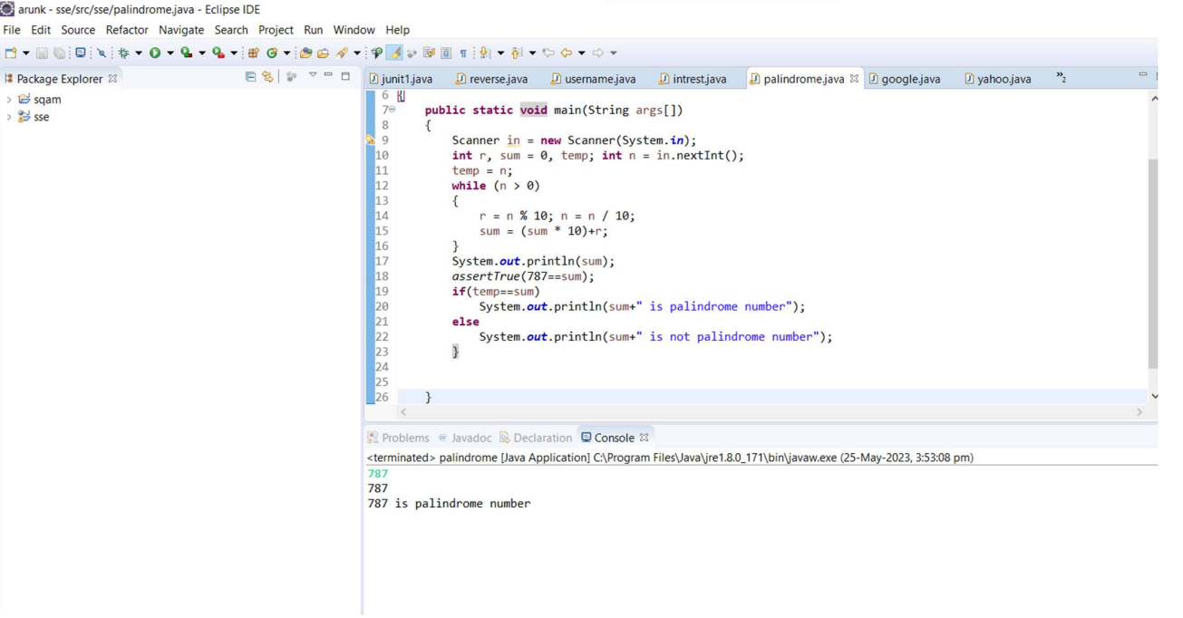

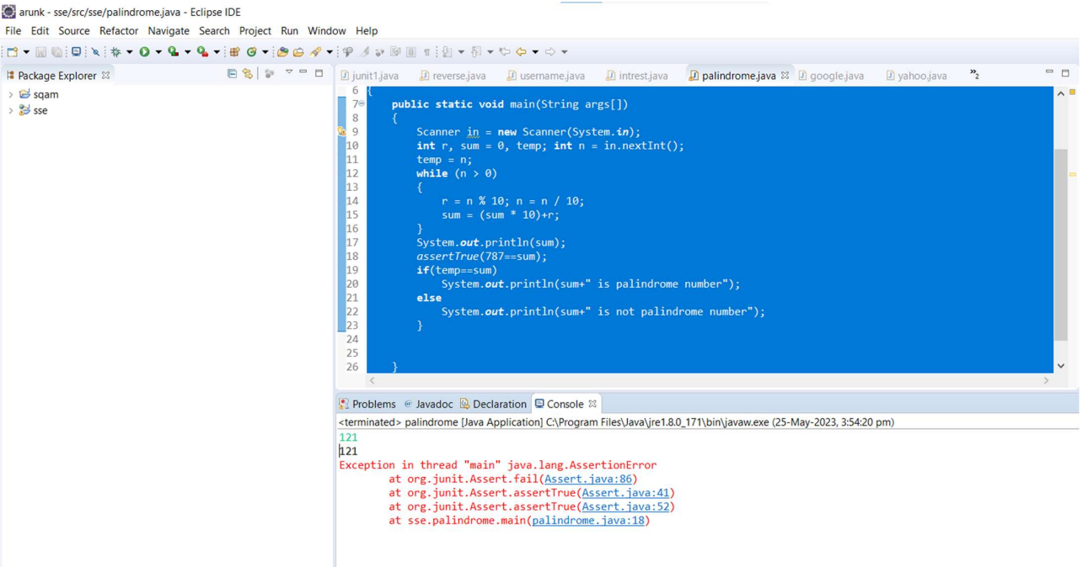

**RESULT:**

Hence the junit Testing Check Whether the given number is palindrome or not performed successfully.